**Inline Policies in IAM :**

These are the customer managed policies which are created by users or customers .Policies are generated in the form of json

**To access the all the buckets in S3 by using Inline policies for particular user:**

We can create the inline policy from IAM dashboard for particular user.

* Go to the IAM dashboard and click on user (to whom give the access) .
* Click on permissions and click on add permissions then click on create inline policy.
* Select the service which service we want to give the access to particular user.
* After modify the json format click on next.
* Enter name of the policy whatever we want.
* Click on create policy.

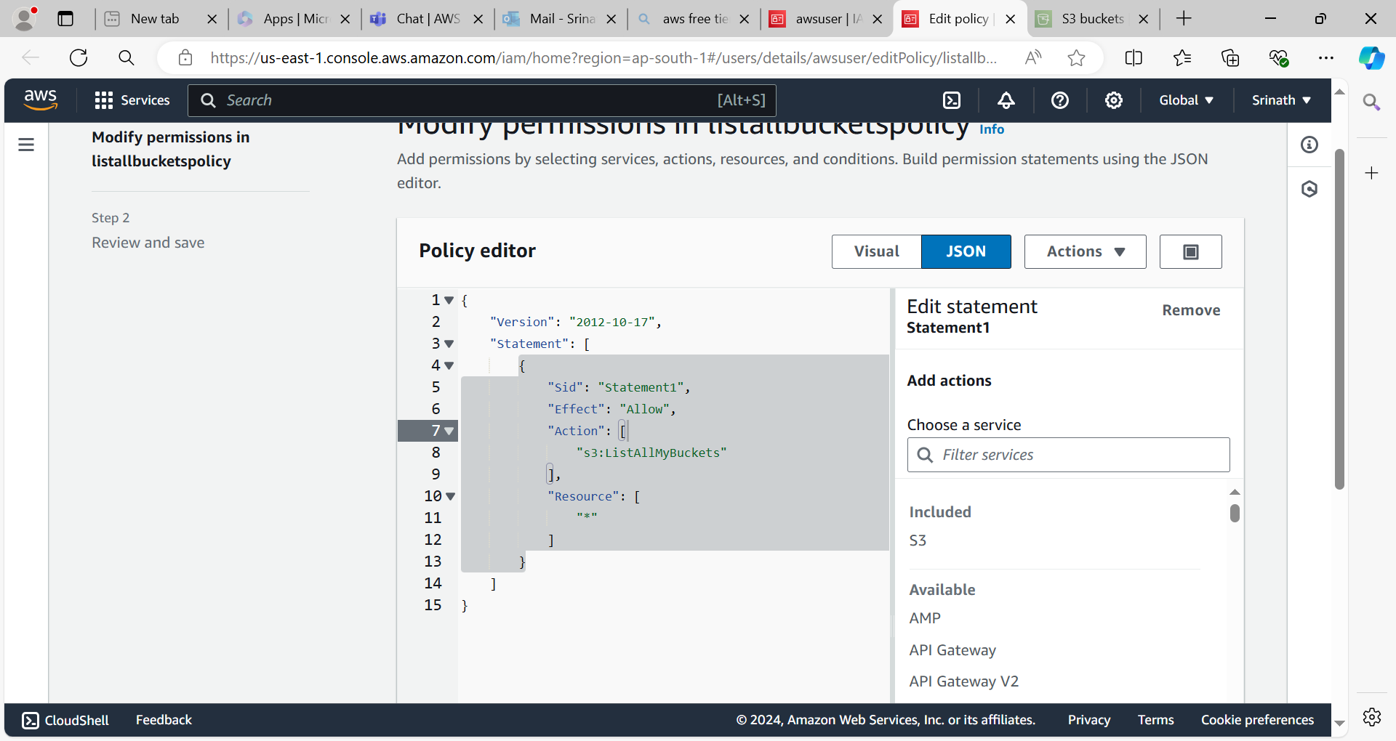

Login to the iam user check whether the s3 buckets are access or not.

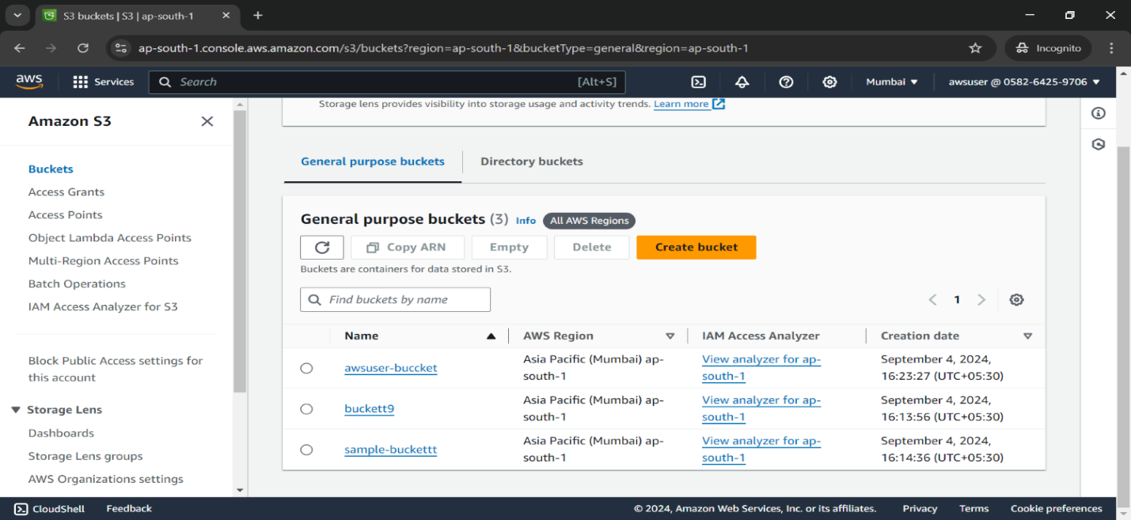

**To Deny the permissions on objects for all buckets in s3 for particular user:**

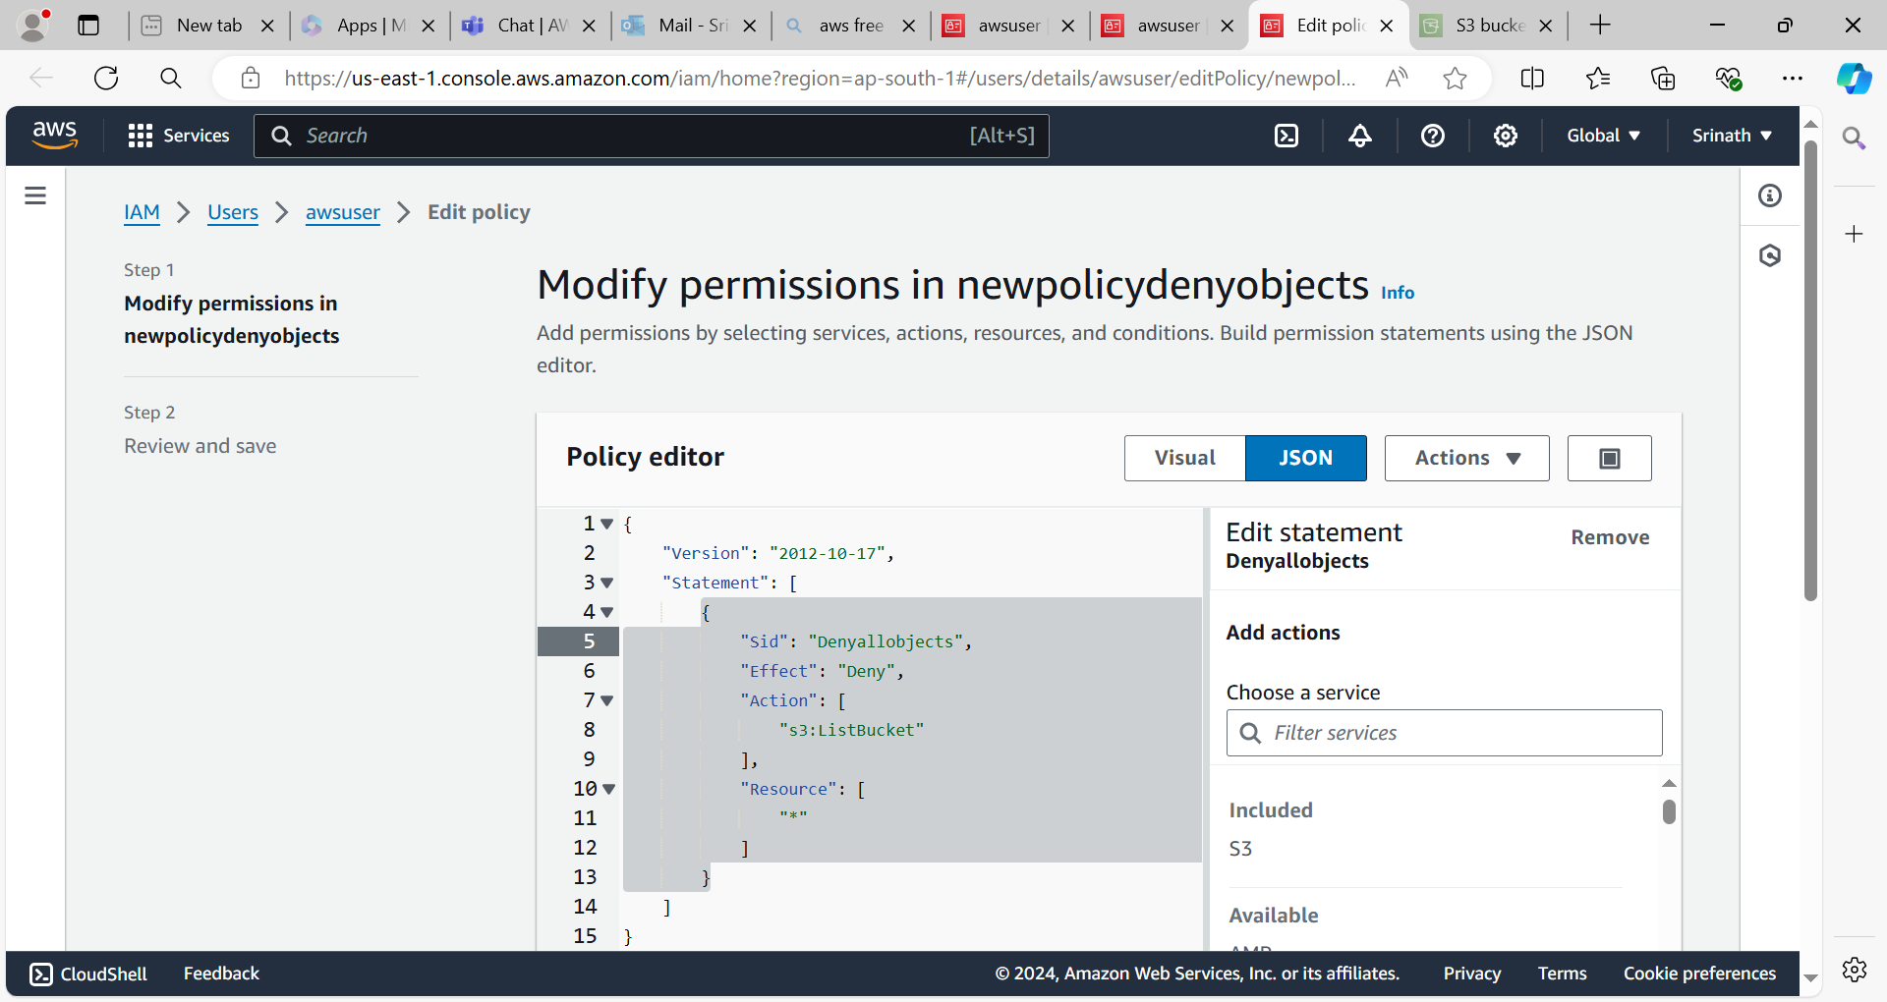

**Check on the IAM user aws account**

